REQUIREMENT SPECIFICATION

1. FUNTIONAL REQUIREMENTS
   1. Play Game

Car Game is based on a simple car game which is enriched by some arcade features in order to entertain the user. Initially, user has 3 healths, appears on a 3 line road. Randomly generated other enemy cars eventually appears randomly on the road. Main purpose of the user is escaping from enemies by using left and right arrow and getting the highest score. User gets points for each second passed alive. Also player will encounter some extras as obstacles and power ups, such as stronger car, water holes, black holes.

* 1. Change Settings

User have chance to change the user’s car. There are multiple choices for the user’s cars in terms of design of the car. There are no extra’s about selecting car by us.

* 1. High Score

Player can see previously recorded highest records, and user cannot see his previous records unless high score is among in the highest scores.

* 1. Pause Game

The game can be stopped by the user, in the pause state, game stops until user starts it again.

* 1. Credits

Gives information about the creators of the program.

User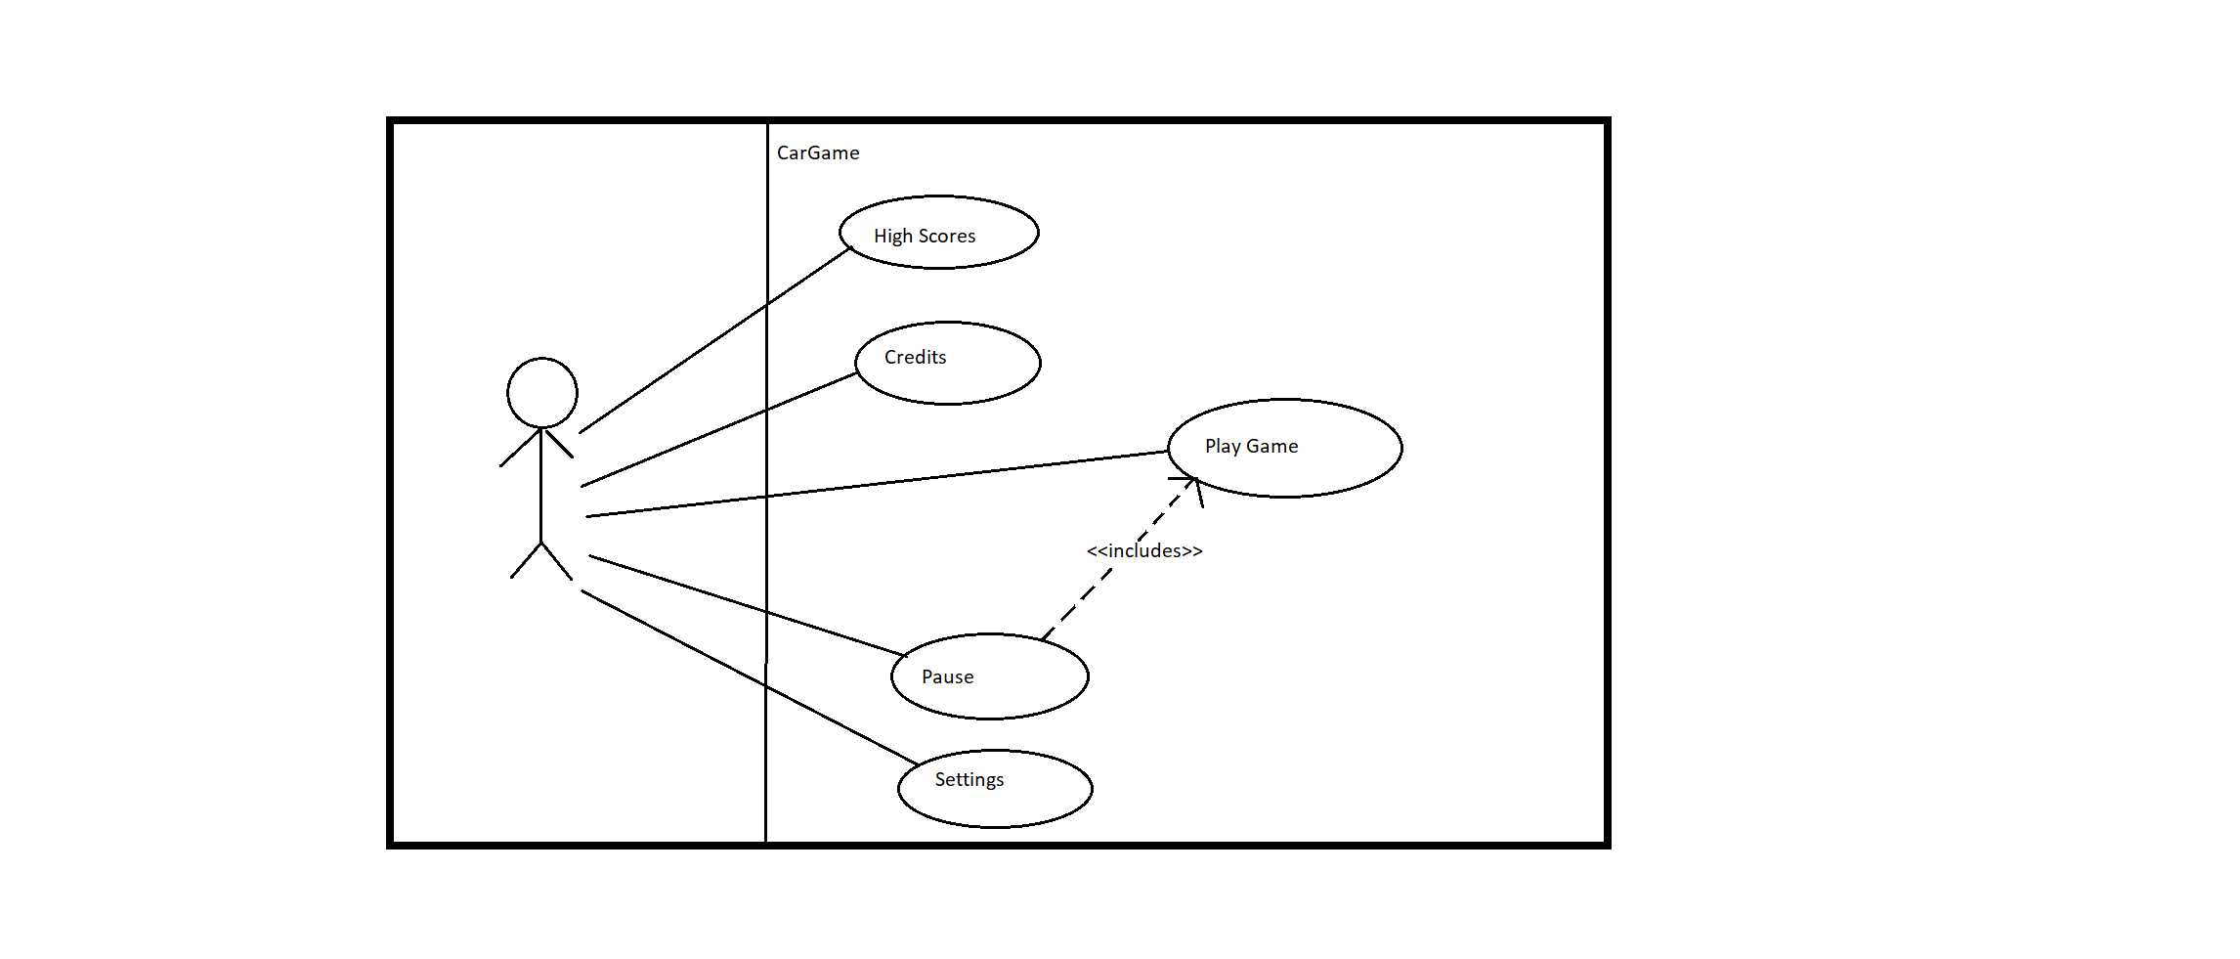

1. Use Case Name : High Scores
   1. Actor : User
   2. Flow of events :
      1. User clicks “High score” button.
      2. System shows the top scores.
   3. Entry Conditions
      1. System records high scores
   4. Exit Conditions :
      1. User clicks “Main Menu” button
   5. Quality Requirements : NONE
2. Use Case Name : Pause
   1. Actor : User
   2. Flow of events :
      1. User clicks “Pause” button
      2. System stops running.
   3. Entry Conditions
      1. System is run by user.
      2. User clicks “Pause “ button
   4. Exit Conditions
      1. Usert clicks “Continue” button;
   5. Quality Requirements : NONE
3. Use Case Name : Settings
   1. Actor : User
   2. Flow of events
      1. User clicks “Settings” button.
      2. System shows the modifiable preferences.
   3. Entry Condition
      1. User clicks “Settings” button
   4. Exit Condition
      1. User clicks “Main Menu” button
   5. Quality Conditions : NONE
4. Use Case Name : Play Game
   1. Actor : User
   2. Flow of Events :
      1. User send message to the system in order to play game
      2. System opens the game
      3. Welcome page opens.
      4. User starts playing the game
      5. System keeps running the game until user lose his all healths or User decides to close the program
      6. If user’s score is evaluated as high score, program records the socre as High Score.
   3. Entry Conditions
      1. User runs the game.
   4. Exit Conditions
      1. User closes the program.
      2. User loses all health points.